Discussion of ideas – Realm

Contents
No table of contents entries found.

Important context
This document is primarily comprised of transcripts from our team discord server that we have used as our primary communication and logging platform throughout the course of the PIGDE module. While they are mostly accurate, there are some aspects of formatting that cannot be transcribed into this document. In these cases, alternative means of formatting for the same emphasis have been utilised to try and keep the record faithful to the original texts.
A series of screen shots have also been included as an appendix to this document should it be useful to view the messages as originally formatted.
All section headings are additions for this document to aid navigation.

24/10

Posts by Skye
Current points under discussion from playtest notes 24/10: Charisma / trading rolls require a nerf. Soldiers are currently a positive feedback loop and become a dominating strategy (bar maybe trade only). Game is significantly faster with 3 players than 2.
Win condition needs to be more difficult to achieve. Current ideas:
- revert to multiple Cities to win.
- introduce a lvl 4 structure win
Forests need to be limited so they are not 3 in a row. Simulated randomness or rule change? Random draw from a set series of arrangements?

2/11

Posts by Fin
I say maybe two possibility’s, we give wrath a bit of the craftmanship and charisma feats. Where we keep it 1 skill point cost still but you can only have one and wrath gives you + 2 to attack rolls. Or you can only take 2 wrath’s

3/11

Post by Skye

Relaying ideas from Fin
Possible recovery turn after attacking to prevent constant attacking and allow opponent to rebuild military

Original posts
Kingdoms could be represented by flags. Flags are altered depending on what starting stat choices - include other teams idea?

Posts by Fin
Like the idea of flags on all the miniatures you own, especially since it means we don’t have to colour a bunch of the different coloured same type figures
Great idea

04/11

Posts by Dylan
I was looking over last week's slides and I was thinking about what fin was saying when he played it in terms of bluffing and hiding cards which are forms of incomplete information and imperfect information and thought it would be good to talk about in the presentation

10/11

Posts by Fin
I was thinking about this, how about within x distance buuut you can push to an extra square provided you feed your soldiers on the journey sacrificing x amount of food per square

13/11

Posts by Dylan
This is just a brain blurt of things not very refined but I just wanted your thoughts before going any further with it
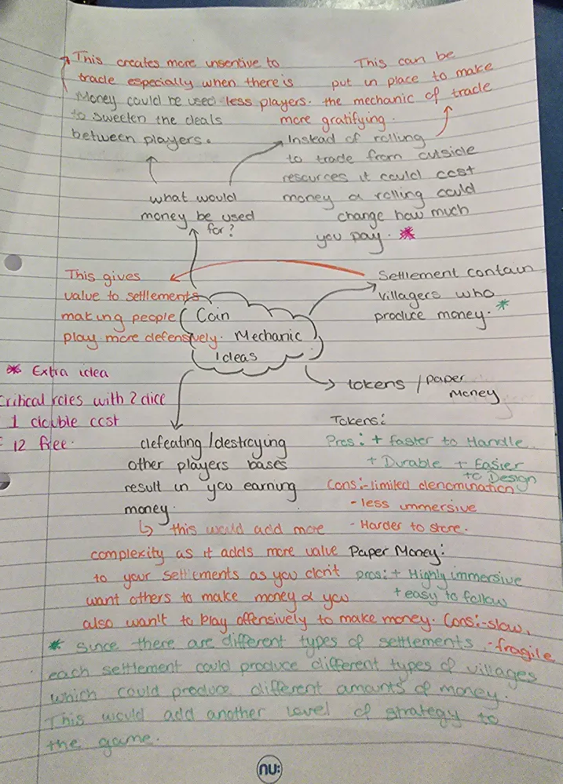

14/11

Posts by Skye
Possibly change / lower the resources required to build city and citadel tier structures. Currently building citadels are the optimal win condition rather than building 3 cities. Game is also at the upper end of the game length tolerance, so speeding up the game may be useful. - based on game 1; 14/11
Need to make official that there must be a space of at least 1 tile open between kingdoms.

17/11

Posts by Skye
Skill idea - save X many soldiers from depletion after battle

21/11

Posts by Skye
Need to rebalance combat with the exhaust mechanic.
- Only exhaust soldiers matched in the wager if larger army wins?
- Modify roll further for greater imbalance?

Posts by Fin
Velcro miniatures discussion
Colour under rim and seperate connectable building tiles
How to show levels??? Is conflict

Posts by Dylan
The cards were visually fun as i was able to bluff easier, but got very unorganised. Holders is an idea

Posts by Fin
Keep attacking rules the same but Increase incentive to attack by allowing the attacking player to attack twice. Dylan who won claims the highest amount of soldiers he possessed during the game was six. This would POSSIBLY balance the state of combat as it would force players to be conscious of defending against aggressive players, providing more incentive of attack. While still keeping the mechanics of combat balanced. It also means from Dylan’s response that should a player try to gain an unfair advantage by only ever betting 1 soldier for defence at every opportunity they have a likely hood of losing up to around a third of their soldiers making them more at risk

